**Exercises**

1. Write a script that creates and calls a stored procedure named **test**. This procedure should include a set of three SQL statements coded as a transaction to reflect the following change: United Parcel Service has been purchased by Federal Express Corporation and the new company is named FedUP. Rename one of the vendors and delete the other after updating the *vendor_id* column in the Invoices table.
   1. If these statements execute successfully, commit the changes. Otherwise, roll back the changes.

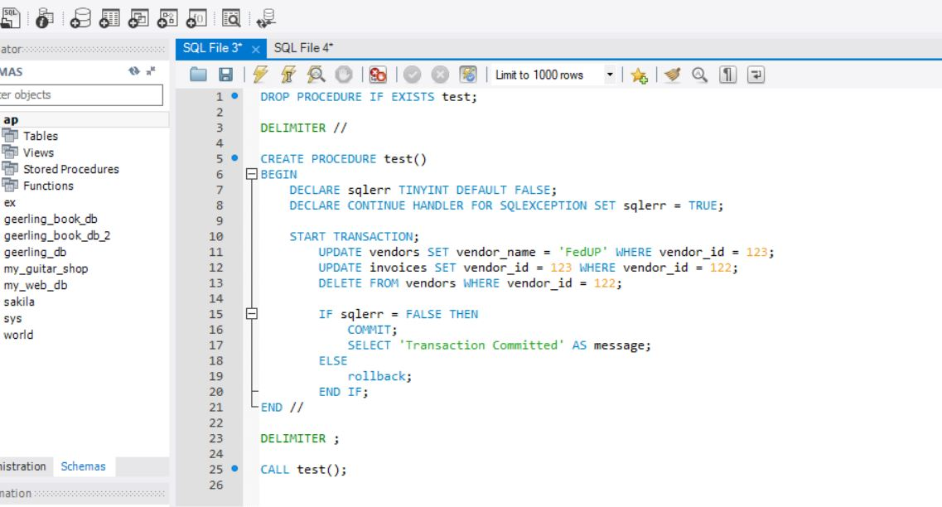

1. Write a script that creates and calls a stored procedure named **test**. This procedure should include a set of two SQL statements coded as a transaction to delete the row with an invoice ID of 114 from the **Invoices** table. To do this, you must first delete all line items for that invoice from the **Invoice_Line_Items** table.
   1. If these statements execute successfully, commit the changes. Otherwise, roll back the changes.

